**Created by Yongtao Zhu (Fall 2022)**

**Colony PCR using Taq DNA Polymerase**

**Day 1**

Draw grids on the bottom of an LB agar (with ampicillin) and patch 20 colonies (less if not enough) using sterile tips from the transformation plates as shown below. Incubate the patched plate at 37C overnight (no more than 24 hours). Keep the plate refrigerated before use.

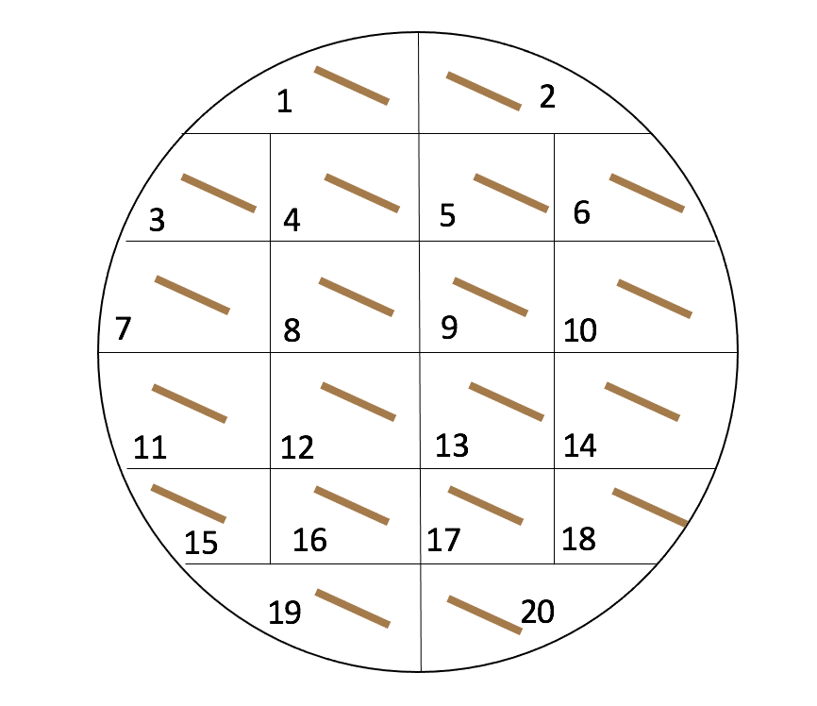

**Day 2**

**Preparation for the DNA templates**

1. Add 20 µl of sterile ddH2O to each microcentrifuge tube and label them with the colony numbers (choose 10 colonies for the 1st PCR).
2. Add ~200 ml dH2O in a 1-L glass beaker (larger containers can also be used). Heat till boiling.
3. Scrape 1/4 of the cells off from each patched colony using sterile tips and suspend them in 20 µl of sterile ddH2O.
4. Insert all tubes on the float and boil for 7 mins (do not cover the beaker).
5. Let the samples cool down and vortex for 20 seconds.
6. Centrifuge at 13000 rpm for 3 mins. Keep the boiled tubes on ice until use.

**Preparation for the PCR**

1. Calculate volumes (and record your work in your lab notebook) needed for the number of reactions you are running. Prepare an extra one as the positive control (genomic DNA template).
2. On ice, make the following master mix (multiply by the number of reactions needed) in a labeled (with primer names) microcentrifuge tube. ** Gently mix the buffer, dNTP, and primers before use. Remember to add larger volumes first. If you are using different sets of primers, each primer set requires a different master mix. Do not take the DNA polymerase out of the freezer before everything else is added in the master mix, and put it back in freezer immediately after use.

**1x Mix (Scale up as needed):**

17.875 µl autoclaved ddH2O

2.5 µl 10 Standard Taq Reaction Buffer

0.5 µl dNTP Mix

0.5 µl Forward Primer (10 µM)

0.5 µl Reverse Primer (10 µM)

* 1. µl Taq DNA Polymerase

Total: 22 µl

Tip: You may add an extra of ~10 µl ddH2O to the final master mix in case there is not enough after distribution in step 10.

1. Flick the bottom of the microcentrifuge tube to mix and spin down your master mix.
2. Label PCR tubes and pipet 22 µl of your master mix into each tube.
3. Add 3 µl of DNA template (**supernatant** of the boiled cells) to each tube (total volume = 25 µl). For the positive control, add 1 µl of genomic DNA and 2 µl of autoclaved ddH2O.
4. Flick the PCR tubes to mix and spin down. Make sure no bubbles are present in the tubes.
5. Turn on the thermocycler. Select Saved Protocols 🡪 ZHU 🡪 TAQ. Check that the reaction parameters are correct (ask for help if they are not). You need to adjust the annealing temperature based on your primers and calculate the extension time based on the product size (1000 bp/min for Taq polymerase).